LAB # 08

Task No 01: Create a payroll system using classes, inheritance, and polymorphism. Four types of employees are paid weekly.

1. **Salaried employees:** Fixed salary irrespective of hours.
2. **Hourly employees:** 40 hours salary and overtime (> 40 hours).
3. **Commission employees:** Paid by a percentage of sales.
4. **Base-plus-commission employees:** Base salary and a percentage of sales.

The information about each employee is his/her first name, last name, and national identity card number. The reset depends on the type of employee.

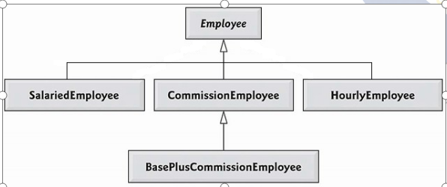

**Step by Step Guidelines:**

**Step 1: Define Employee Class.**

* Being the base class, Employee class contains common behavior. Add firstName, lastName and CNIC as attributes of type String.
* Provide getter & setters for each attribute.
* Write default & parameterized constructors.
* Override toString() method as shown below:  
  public String **toString**( ) {

return firstName + “ ” + lastName + “ CNIC# ” + CNIC ;

}

* Define earning() method as shown below:  
   public double **earnings( )** {   
   return 0.00;

}

Step 2: Define SalariedEmployee Class.

* Extend this class from Employee class.
* Add weeklySalary as an attribute of type double.
* Provide getter & setters for this attribute. Make sure that weeklySalary never sets to negative value. (Use if)
* Write default & parameterize constructor. Don’t forget to call default & parameterize constructors of Employee class.
* Override toString() method as shown below:  
  public String **toString( )** {

return “\nSalaried employee: ” + super.toString();

}

* Override earning () method to implement class specific behavior as shown below:

public double **earnings**() {

return weeklySalary;

}

Step 3: Define HourlyEmployee Class.

* Extend this class from Employee class.
* Add wage and hours as attributes of type double.
* Provide getter & setters for these attributes. Make sure that wages and hours never set to a negative value.
* Write default & parameterize constructor. Don’t forget to call default & parameterize constructors of Employee class.
* Override toString() method as shown below

public String **toString**() {

return “\nHourly employee: ” + super.toString();

}

* Override earning () method to implement class specific behaviour as shown below:

public double **earnings**(){

if (hours <= 40){

return wage * hours;

}

else{

return 40*wage + (hours-40)*wage*1.5;

}

}

Step 4: Define CommissionEmployee Class.

* Extend this class form Employee class.
* Add grossSales and commissionRate as attributes of type double.
* Provide getter & setters for these attributes. Make sure that grossSales and commissionRate never set to a negative value.
* Write default & parameterize constructor. Don’t forget to call default & parameterize constructors of Employee class.
* Override toString() method as shown below:  
  public String **toString**( ) {

return “\nCommission employee: ” + super.toString();

}

* Override earning () method to implement class specific behaviour as shown below:

public double **earnings**() {

return grossSales * commisionRate;

}

Step 5: Define BasePlusCommissionEmployee Class.

* Extend this class form CommissionEmployee class not from Employee class. Why? Think about it for yourself.
* Add baseSalary as an attribute of type double.
* Provide getter & setters for these attributes. Make sure that baseSalary never sets to negative value.
* Write default & parameterize constructor. Don’t forget to call default & parameterize constructors of Employee class.
* Override toString() method as shown below:  
  public String toString( ) {

return “\nBase plus Commission employee: ” + super.toString();

}

* Override earning() method to implement class specific behavior as shown below:

public double **earnings**() {

return baseSalary + super.earning();

}

Step 6: Putting it all Together.

public class PayRollSystemTest {

public static void main (String [] args) {

Employee firstEmployee = new SalariedEmployee("Usman" ,"Ali","111-11-1111", 800.00 );

Employee secondEmployee = new CommissionEmployee("Atif" ,"Aslam", "222-22-2222", 10000, 0.06 );

Employee thirdEmployee = new BasePlusCommissionEmployee("Rana", "Naseeb", "333-33-3333", 5000 , 0.04 , 300 );

Employee fourthEmployee = new HourlyEmployee( "Renson" , "Isaac", "444-44-4444" , 16.75 , 40 );

// polymorphism: calling toString() and earning() on Employee’s reference

System.out.println(firstEmployee);

System.out.println(firstEmployee.earnings());

System.out.println(secondEmployee);

System.out.println(secondEmployee.earnings());

System.out.println(thirdEmployee);

// performing downcasting to access & raise base salary

BasePlusCommissionEmployee currentEmployee =

(BasePlusCommissionEmployee) thirdEmployee;

double oldBaseSalary = currentEmployee.getBaseSalary();

System.out.println( "old base salary: " + oldBaseSalary) ;

currentEmployee.setBaseSalary(1.10 * oldBaseSalary);

System.out.println("new base salary with 10% increase is:"+ currentEmployee.getBaseSalary());

System.out.println(thirdEmployee.earnings() );

System.out.println(fourthEmployee);

System.out.println(fourthEmployee.earnings() );

} // end main

} // end class

Code:

Main:

Class (Parent):

Class (Child):

Output:

Task No 02: You must implement the following diagram including some attributes and other functions:

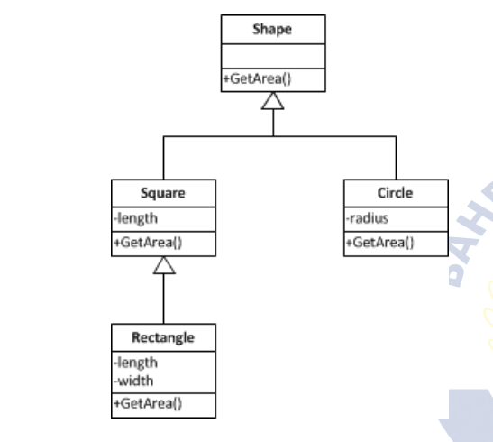

Code:

Main:

Class (Parent):

Class (Child):

Output: